# ECE 162 Week 7 – Time Constant of a RC Circuit

Name: Brian Loughran ([btl217@lehigh.edu](mailto:btl217@lehigh.edu))

## Purpose

In this lab we will determine the time constant of a simple RC circuit.

## Theory

In this lab we will be analyzing the time constant of a simple RC circuit. Below is a diagram of the circuit that we will be analyzing in this lab (Figure 1):

Figure 1

This is the basic format for any simple RC circuit. For the circuit that we are analyzing in lab, we are using a value of R = 1kΩ, C = 10μF, V = 8V.

Moving on to the time constant analysis of the system, the time constant is the time that it takes for 63.2 % of the maximum charge to be transferred to the capacitor. After 4 time constants, the capacitor reaches around 98% of its maximum charge, and at this point it can usually be approximated as fully charged. The time constant (τ) for a simple RC circuit can be found using the following equation (equation 1).

$$τ=R_{th} C (eq.1)$$

In this equation, Rth represents the Thevenin resistance as seen by the capacitor, and C represents the value of the capacitor in Farads.

Also of interest is the equation of transient voltage across the capacitor. This equation can give us a good model of how the capacitor will act when it is charging, and a similar equation can be written while the capacitor is discharging. Each equation is different, however, and in this lab I will only discuss the equation for charging a capacitor in a simple RC circuit. This system simplifies to a first order differential equation, and the general solution for this differential equation is shown below (equation 2):

$$V_{C}\left(t\right)=\left[V_{i}\left(0^{+}\right)- V_{C,SS}\right] e^{\frac{-t}{τ}}+ V_{C,SS} (eq.2)$$

Where $V_{i}\left(0^{+}\right)$ represents the initial voltage of the capacitor, and $V_{C,SS}$ represents the voltage of the capacitor at steady state (after approximately 4 time constants have passed).

## Experimental Method

* Build the circuit shown in Figure 1 (also Figure 6.3(i) in the textbook)
* Connect the ends of the capacitor to the data acquisition board
* Flip the switch
* Monitor charging voltage across the capacitor using the DAQ until the capacitor reaches “steady state”
* Flip the switch (again)
* Monitor discharge voltage across the capacitor

## Diagram

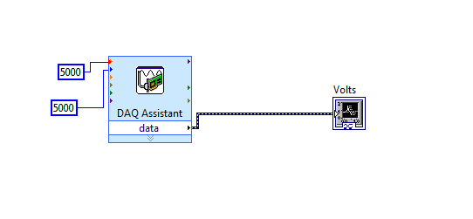Below (Figure 3) is a diagram of the LabVIEW VI which we used for this lab. While this VI is quite simple (just data acquisition and display), they can get far more complicated as you increase functionality and computation, which makes LabVIEW an incredibly versatile tool for signal processing.

Figure 3

## Results

Using the values for Rth and C for the circuit, we can find the theoretical time constant for the circuit is .01 seconds. This will later be compared to the experimental time constant.

Next we plug in values to the equation of transient voltage across the capacitor. Something to note in writing the equation of transient voltage across the capacitor, is that our voltage never settled at zero. The voltage for our circuit settled at 1.4 V, which is the value plugged in for V(0+) in equation 2. Plugging in voltage and the time constant yield the following equation (equation 3):

$$V_{C}\left(t\right)=\left[1.4-8\right] e^{-10t}+ 8 (eq. 3)$$

Simplifying, we get equation 4:

$$V_{C}\left(t\right)= 6.6 \left[ 1- e^{-10t}\right]+ 1.4 (eq.4)$$

Data for charging and discharging the capacitor was taken using the data acquisition unit. This was connected in parallel with the capacitor to measure voltage. A full charging and discharging cycle is shown in figure 4 below:

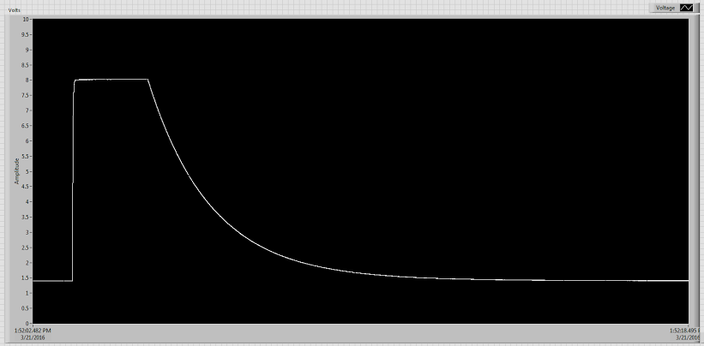

Figure 4

The cycle begins with the capacitor fully discharged. As you can see, the minimum value of the capacitor charge for our circuit is 1.4 V. This is the value that was plugged into equation 2 for V(0+). Then the switch was flipped, allowing the capacitor to see the 8V from the voltage source. We waited a “long time”, so the capacitor could fully charge, which is the plateau you see at the top of the chart. The maximum voltage is 8 V, which makes sense as this is the applied voltage across the capacitor. The switch was then flipped again, and the capacitor began to discharge. This took significantly longer than the charging portion, but we again waited a “long time” to allow the capacitor to go back down to 1.4 V.

In this lab we are not really dealing with the discharging cycle. The time constant we calculated earlier correlates with the charging cycle. Zooming in on the charging cycle, we can see a bit more detail (Figure 5):

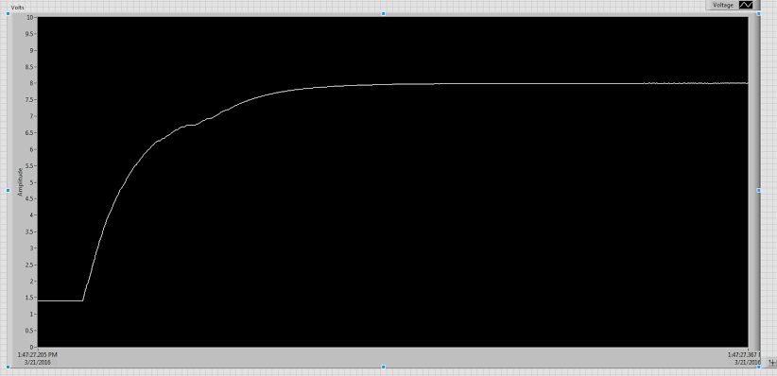

Figure 5

This is a zoomed in version of the previous figure (Figure 4), and shows only the charging cycle. Here we can see more clearly the way that capacitors charge, which is similar to the way that they discharge. It is simply and exponential function based on the time constant, minimum voltage, and maximum voltage. You can see the time at which the switch is flipped, indicated clearly by the sudden increase in voltage across the capacitor. If you set this to time t = 0, the equation of transient voltage across the capacitor should closely match the charging cycle. As I mentioned earlier, the time constant is the time that it takes for the capacitor to reach 63.2 % of its maximum charge. So, by plotting only the time it takes to go from 1.4 V to 63.2 % of maximum charge, we can get an experimental value for the time constant. This plot is shown below (Figure 6):

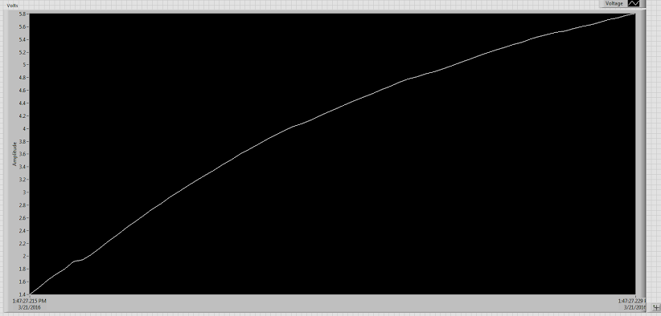

Figure 6

By checking the time stamps in the bottom right and left hand of the graph, we can see that the experimental time constant is .014 seconds. This is relatively close to the calculated time constant .01s, so we know that we are looking at the right thing. The time constant for the discharge cycle was approximately 1.7s, so we know this is not right.

A sketch of the discharge voltage is shown below (Figure 7)

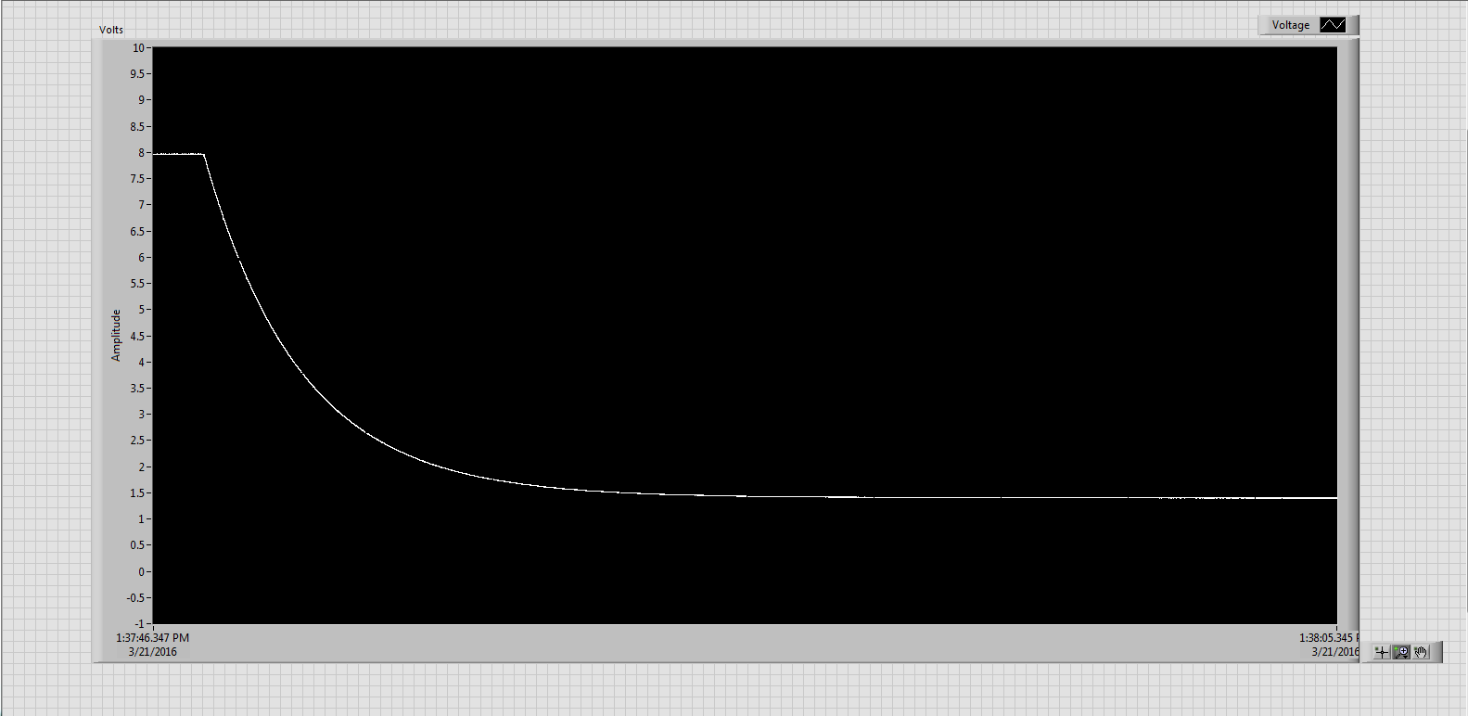

Figure 7

## Discussion

## First in the discussion we can compare the calculated and experimental time constant. The two time constants are shown in Table 1 below for the sake of convenience:

|  |  |
| --- | --- |
| Calculated | Experimental |
| .01 s | .014 s |

Table 1

Now the first thing to note is that there is a percent error of 40 %. In general, this would not be good. But there are some things to consider. First, this 40 % error is also .004 seconds, or 4 milliseconds. There are many things which could cause a 4 millisecond error. For example, the time constant is based on the resistance value, which could increase with losses in wires and through the DAQ. This would affect the time constant, and maybe throw off the value by a bit.

The next thing to consider is the time that it takes to discharge. As discussed before, this is far longer than the time that it takes for the capacitor to charge up. This is in part due to the way that the circuit is designed. When the switch is active, current goes directly through the 1 kΩ resistor. This gives a time constant which is dependent on the resistance of the resistor we are using. When the switch is disconnected, the current flows through the DAQ to the ground. The DAQ has a resistance which is not given, therefore has its own time constant. This is why the discharge time is different from the charging time.

## Conclusion

This lab was interesting because it produced such a clear picture of what was actually supposed to be happening. We are basically charting a first order linear differential equation, and the plots were smooth on both the charging and discharging side. Using the DAQ, we were able to easily and clearly see the changes in voltage across the capacitor. This was done by creating a VI in LabVIEW to take in signals from the DAQ and process those signals into a plot which could be formatted to our needs. This gave great data on different waveforms, and the plots that were created were very close to the idea case, with nothing more than minor imperfections.